Question Bank
Chapter 10
Neuroeconomics: Pointing Toward a Unifying Framework for Decision Making

Think Break Questions (from Book: p. 144)

1. Suppose you run a student dining hall and you’d like to increase the consumption of fruits and vegetables. Using figure 10.1, provide two specific system 1 stimuli and two specific system 2 stimuli you think would achieve this objective.

2. In the context of figure 10.1, explain why you think some of the stimuli may be more effective than the others?

3. Again in the context of figure 10.1, identify two moderators that may undermine your objective.

4. Using a demand diagram, similar to figure 10.2, show what you think would happen to demand for fruits and vegetables based on increasing the stimuli in question 1.

Multiple Choice Questions

1. The most basic property of a theory is

a. it predicts with accuracy some phenomenon.
b. it separates the world into relevant and irrelevant factors for explaining some phenomenon.
c. it explains how some phenomenon may be controlled.

2. The computational view of the brain conceptualizes the brain as an information processing machine that is goal driven in answering decision problems.

a. True
b. False

3. All decision problems have four core elements. They are

a. the decision objective, the information input (stimuli), the information processing, and the decision output.
b. the decision objective, the constraints, the tradeoffs, and the decision output.
c. the environment, the decision objective, the tradeoffs, and the decision output.

4. Neuroeconomics utilizes methods and theories from neuroscience, psychology, economics, and computer science to better understand the process of decision making and final choices.

a. True
b. False

5. A cognitive resource allocation model assumes that at any point in time cognitive resources are unlimited and the individual attempts to allocate this resource only focusing on the benefits of the allocation in making a decision.

a. True
b. False

6. In the dual processing model of decision making, system 1 is

a. slow, reflective, and deliberate and expends many cognitive resources.
b. fast, reflexive, and automatic and expends little cognitive resources.
c. none of the above

7. Given system 2 uses less cognitive resources than system 1, there is a preference for using system 2 over system 1.

a. True
b. False

8. As cognitive resources are depleted, individuals attempt to conserve resources by switching from system 2 to system 1.

a. True
b. False

9. Cognitive load refers to the amount of attention, focus, and effort a decision requires.

a. True
b. False

10. Health decisions are associated with system 2 and hedonic decisions are associated with system 1.

a. True
b. False

11. The behavioral economic effects, such as environmental effect or default effect, are mainly processed with

a. system 1.
b. system 2.

12. The neoclassical resource constraint based factors, such as price, income, time, are mainly processed with

a. system 1
b. system 2

13. The default effect, or more generally habitual behavior, may be considered optimal from a cognitive resource allocation perspective.

a. True
b. False

14. A moderating variable is one through which an effect operates

a. True
b. False

15. In the context of the cognitive allocation model, poverty may have two effects on decisions. First, it can limited feasible choices and second, it can act as a cognitive tax because more cognitive resources are required to monitor financial standing and financial problems thus leading to a lower quality decision making.

a. True
b. False

16. Decreasing cognitive effort in a choice environment tends to reduce the demand for a food, ceteris paribus

a. True
b. False

Short Answer Questions

1. Classify the eight behavioral effects from chapter 9 in terms of which system likely is responsible for that effect. Justify your classifications based on principles covered in this chapter.

2. In this chapter it is claimed that hedonic effects are processed by system 1, but health effects are processed by system 2. Explain the logic of this claim.

3. One of the most common patterns in weight loss is that individuals will initially lose weight, but then over time regain the weight. Using the concept of a cognitive resource allocation model, explain how limited cognitive resources contribute to this phenomenon. Explain why might this effect be accentuated if the individual is poor?

Discussion Questions

1. In your new job as the Director of Nutrition for the Montgomery County School System, you are evaluating two programs to improve nutrition in the schools proposed by two different schools. School A is proposing a nutrition education campaign where students are taught about MyPlate. School B is proposing to move the salad bar, which has fruits and vegetables, to the middle of the dining area. Tomorrow you are to sit down with each school and discuss their plan. Using the diagram below discuss the advantages and disadvantages of each proposal.
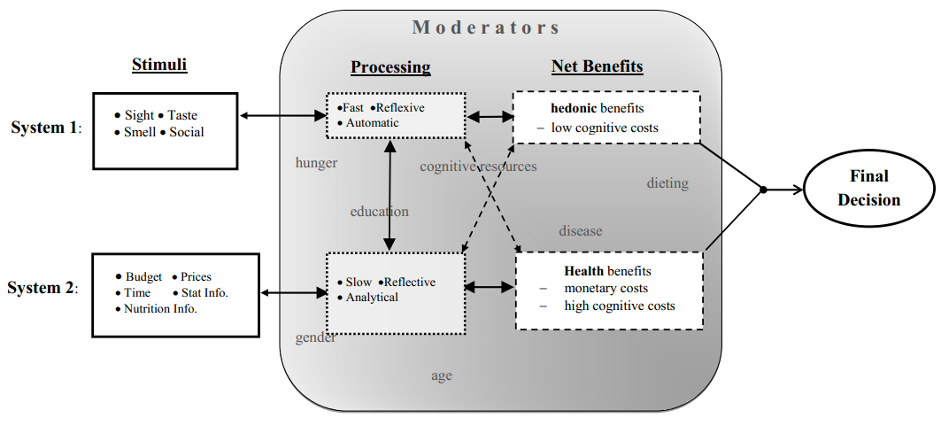

2. Poverty imposes an implicit “cognitive tax” on individuals trying to making healthy food choices. Explain the idea of a cognitive tax of poverty and using a demand curve, show and explain how an income subsidy will have two effects on the demand for healthy food.

